3GPP TSG-RAN WG1 Meeting #125 R1-2604278
Dalian, China, May 18-22, 2026

Agenda Item: 10.8.2
Source: Huawei, HiSilicon
Title: Sensing integration with communication
Document for: Discussion and Decision

Introduction
The RAN study on 6G scenarios and requirement documented the sensing related use cases and requirements in the TR [1] as follows:

5.1.17 Sensing-related requirements
Sensing-related capabilities are measured in terms of the following technical performance requirements:
• Detection Probability and False Alarm Probability: Detection probability is the probability of correctly detecting the presence of the sensing target when it is present, and false alarm probability is the associated probability that a sensing target is detected when no corresponding true sensing target is present.
• Horizontal/Vertical Localization Accuracy: It is defined as the absolute difference between the estimated horizontal/vertical location and the actual horizontal/vertical location of the sensing target. The value of localization accuracy shall be obtained assuming 90% confidence level, which is the 90th percentile point of the CDF of the location estimation error. Both the horizontal and vertical localization accuracy are estimated based on Cartesian coordinates.
• Velocity Accuracy: It is defined as the absolute difference between the estimated velocity and the actual velocity of the sensing target. The value of velocity accuracy shall be obtained assuming 90% confidence level, which is the 90th percentile point of the CDF of the velocity estimation error.
In the above technical performance requirements, the sensing target is a passive object, which is not connected to the radio network for communication.
The minimum requirements for Sensing-related requirements are summarized in Table 5.1.17-1.
Table 5.1.17-1: Sensing-related requirements
 | Indoor Factory | Urban Macro
Detection Probability | 95% | 95%
False Alarm Probability | 5% | 5%
Horizontal Localization Accuracy | 2 m | 5 m
Vertical Localization Accuracy | N/A | 8 m (Note 1)
Velocity Accuracy | 2 m/s | 4 m/s

5.4.4 Sensing
Editor note: More sensing use cases can be included depending on further discussion.
The 6GR and 6G RAN architecture shall at least support use cases of
- detection and/or tracking of passive objects, at least including UAVs, human, vehicles and AGVs
- communication assistance.

For the RAN1 study on 6G Radio, the sensing related objectives agreed for the study [2] are as follows:
(9) Sensing – Studies to be based on use cases and associated requirements, as defined in [TR38.914]
- PHY functions and procedures for sensing technology (e.g., waveform. reference signals, measurement feedback, etc…) [RAN1, RAN4]
- Evaluate sensing performance and if necessary, extend channel modelling, for the selected use cases [RAN1]
- Aspects of integration with communication services [RAN1]
- higher layer procedures and protocol aspects [RAN2]
- RAN4 aspects of sensing including RF, coexistence, and testability in coordination with other WGs [RAN4]
Note: RAN1 identify detailed requirements, if triggered by TSG RAN

As written in the SID [2], aspects of integration with communication services are to be studied in RAN1. This contribution discusses what should be considered for integrating sensing and communication.
The use cases to be studied for 6GR can be categorized into two types. One is detection/tracking of moving objects, such as UAVs, vehicle, and AGV and the other one is sensing assisting communication.

Sensing modes
From 6GR air interface perspective, the wireless time/frequency/spatial resource is expected to be efficiently used for both sensing and communication performance irrespective of the sensing modes to be invoked.
Based on the two categories of use cases scoped in 6G, aNB-UE and UE-aNB bi-static sensing should be prioritized for the study.
Proposal 1: aNB-UE and UE-aNB bi-static sensing should be prioritized for 6GR ISAC study.

For aNB-UE or UE-aNB bi-static sensing modes, the sensing results in terms of location or speed estimation rely on the aNB/UE locations. When further consider multiple links (e.g., aNB-UE1, aNB-UE2, etc.) fusion, which UEs will be involved in the sensing task is an issue that needs to be studied. Given UE’s location is the prerequisite for sensing results calculation and core network is responsible for maintaining UE positioning procedure, we presume SA2 will lead and study this issue first but can further coordinate with RAN when needed. In terms of RAN1 evaluations for sensing performance, the ideal UE location assumption could be prioritized.
Proposal 2: How UE location is known for aNB-UE or UE-aNB bi-static sensing modes for sensing result calculation in Core Network can be studied first in SA2 and further coordinated with RAN when needed.

Air interface resources for sensing
Agreement:
- On RS for ISAC, study at least the following aspects, considering sensing performance, resource overhead and impact to communication
  - RS for communication is reused for sensing
  - Enhanced RS for sensing, taking reuse of RS for communication as starting point
    - Note: Part of or all of the RS may be used for communication purpose, and it does not mean the final decision on whether the enhanced RS is used for communication purpose is to be made in this agenda.
  - Dedicated RS for sensing

For the two categories of use cases, detection/tracking of moving targets needs to estimate doppler to calculate the velocity but the sensing assisting communication normally does not. Therefore, the former case is more demanding in terms of the time domain air interface resources for sensing measurement.
For more information, refer to the theoretical analysis on the required resource is calculated and summarized in Table 1 based on the sensing requirement.
Table 1: The required resource pattern for sensing
Sensing requirement |  | Required resource pattern
Range ambiguity | About 1000m | Frequency density  $$F_{density}=\frac{Range ambiguity*SCS\left(30kHz\right)*12}{c}$$ | ≥1 RE per RB
Velocity ambiguity | Moving speed up to 120km/h  Required ambiguity range:  -120km/h~120km/h | Time domain density  $$T_{density}=\frac{λ}{4v_{ambiguity}}$$ | ≤0.32ms
Velocity resolution | 1m/s | CPI (Coherent processing interval)  $$T_{CPI}=\frac{λ}{velocity resolution}$$ | ≥43ms
Coverage | Co-site between 7GHz and 5G mid-band | Lower PAPR | Lower PAPR

Based on the above table, reusing the NR CSI-RS or SRS pattern in frequency domain can meet the maximum ranging requirement with ambiguity. However, the MIMO topic is discussing the potential sparser communication RS design in 6GR for overhead reduction, which would probably turn out to cause the ranging ambiguity for sensing.
For 6GR study on the air interface resource for sensing, the physical channel/signal for sensing in general could be categorized into two types. Type1 resource is sensing performance oriented, which is generally not needed for communication, e.g., additional time domain reference signal that enables detection of moving targets but not needed for CSI acquisition for communication. Type2 resource is shared with communication and the design is expected to provide good performance for both sensing and communication. Both types should be studied for 6GR ISAC.
Proposal 3: 6GR ISAC should study two types of wireless resources (i.e., physical channel/signal) for sensing:
- Type1 resource is sensing performance oriented, e.g., additional time domain reference signal that enables detection of moving targets but not necessarily needed for communication.
- Type2 resource is shared with communication and the design is expected to provide good performance for both sensing and communication.

Detection/tracking moving objects
Type1 resource as discussed are potentially needed additionally for sensing moving targets. However, it does not preclude to use Type2 resources for detection/tracking moving targets.

4.1 Type1 resources for sensing oriented
As discussed above, measuring doppler necessitates coherent processing of physical signals in time domain, which would result in larger time domain resources overhead that is not needed and expected to be avoided in general for communication. Therefore, the signals on such symbols could be designed for sensing performance oriented and the impact on communication can count the sensing resource overhead only.
Proposal 4: 6GR ISAC study on Type1 resources for optimal sensing performance oriented should focus on using UL/DL reference signals for sensing.

Proposal 5: The study on using UL/DL reference signals for Type1 resources for sensing performance oriented includes the RS patterns and RS sequences.
- Performance for sensing is the optimization objective.
- Impact to communication is the resource overhead for sensing.

4.2 Type1 measurement report
Agreement:
- On measurement report for ISAC, study at least the following aspects and applicable scenarios (e.g., sensing modes, targets, etc.) from RAN1 perspective.
  - Measurement reporting mechanism from UE
    - Option 1A: The UE measurements and/or assistance information if needed from UE can be directly sent to aNB
    - Option 1B: The UE measurements and/or assistance information if needed from UE can be sent to SF
  - Measurement reporting mechanism from aNB
    - Option 2A: The aNB measurements and/or assistance information if needed from aNB can be directly sent to UE
    - Option 2B: The aNB measurements and/or assistance information if needed from aNB can be sent to SF
  - The study may require cross-WG coordination.
  - Note: combination of multiple options is not precluded.
  - Note: measurements in each option may be different

The Type1 measurement report targets the use case of detection/tracking, for which the measurements are reported to core network that is expected to be responsible for initiating the sensing measurement and calculating the sensing results. This applies to aNB-UE and UE-aNB bi-static sensing mode and to aNB mono-static.
For aNB-UE bi-static sensing mode, UE measures the RS and reports the measurement to the core network via aNB but aNB does not need to see nor use such information. For UE-aNB bi-static and aNB mono-static sensing mode, aNB measures the RS and reports the measurement to core network.
Proposal 6: The Type1 measurement report targets the use case of detection/tracking, for which the measurements are reported to core network that is expected to be responsible for initiating the sensing task and calculating the sensing results.
- For aNB-UE bi-static sensing mode, UE measures the RS and reports to core network via aNB but aNB does not need to use such information.
- For UE-aNB bi-static mode, aNB measures the RS and reports to the core network.

Sensing assisting communication
On sensing assisting communication, the following proposal was discussed briefly without agreement reached.
[FL2][H] Proposal 4.9-1-rev3
- For the purpose of study, companies are encouraged to bring up usage scenarios for sensing assisted communication. For each usage scenario, please input at least the following aspects
  - Which feature of communication is to be assisted?
  - Which sensing measurements are useful for the assistance?
  - How the sensing measurements are used to assist the feature of communication?
  - Up to company to report the additional impact to physical layer designs, if necessary
- Note: whether/how to evaluate a usage scenario is to be discussed in 10.8.1

This use case is more distinct from the case of sensing UAV in 5GA compared to detection/tracking other representative moving objects for 6GR study.

5.1 How sensing assists communication
- What sensing could contribute to assist communication
In wireless communication propagation channel, the dominant power propagation paths are often determined by the direct path between Tx and Rx and static features as shown in Figure 1, such as buildings and terrain, which provides stable and strong paths in the whole channel, e.g., the LOS path and reflection path by the buildings. Such channel paths could keep stable during a long-time duration at nearby locations. Meanwhile, the communication and aNB-UE bi-static sensing share the same propagation channel and the UE/BS measures the same channel for different purposes.
Therefore, one commonality between communication and sensing is the same propagation channel. For 6GR, it may be beneficial to leverage such common propagation channel measurement if provided by sensing as assistance information to assist communication.
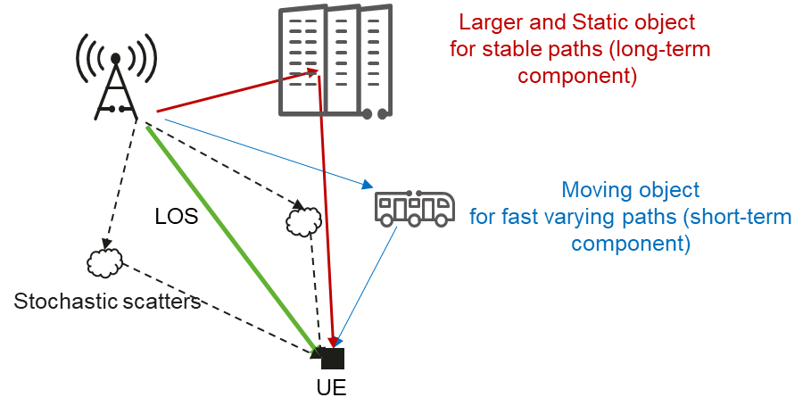
Figure 1: Wireless propagation channel for communication and sensing.

- What use cases sensing can assist
Sensing can provide the measurements from multiple BS-UE links so as to derive propagation channel information. With such information as a priori acknowledge, UE may reduce some measurements for power saving in some cases, e.g., for assisting mobility or beam management, assisting CSI acquisition etc. Sensing assisting communication framework is illustrated in Figure 2.
Figure 2: High-level framework for sensing assisting communication.
- Sensing measurement: In aNB to UE bi-static sensing, sensing and communication share the same propagation channel. The sensing measurement results can be treated as one type of channel information from which sensing targets are identified by network. The large and static objects such as the buildings provide the stable and spatial consistent channel properties.
- Propagation channel acquisition: The propagation channel information can be derived by the BS-UE sensing measurements, e.g., regenerating the channel components for the area in the cell by the AI/ML and/or raytracing-like method, or can even be fine-tuned by the sensing measurement results if needed.
- Channel information assisting communication: Once the propagation channel information is derived, the relevant equivalent channel properties, e.g., RSRP or the associated beam index, could be converted as well and could be taken as a priori knowledge to reduce the measurement overhead and further reduce the power consumption.
Different sensing assisting communication features are investigated in the urban grid scenario with the Rel-19 ISAC channel model.
- Sensing assisting mobility
The key simulation assumptions are summarized in Table 2.
Table 2: Key configurations of the simulation
Configurations | Values
Scenario/layout | Urban grid with ISD500m defined in Rel-19 ISAC channel model
Channel model | ISAC channel
Static object | EO type-2
Assisted channel information | Measurement relaxion information, e.g., measurement relaxion indicator, RSRP, measurement candidate set, measurement period, etc.
Full measurement | e.g., Serving cell RSRP <= -95dB
Relaxed measurement | e.g., Serving cell RSRP <= -95dB & Measurement relaxion information

The counterpart to be compared to is the full measurement case. For example, when the serving cell RSRP is lower than a certain threshold of -95dB. UE needs to measure the RSRP of all the configured cells. Now that the prior information of RSRP of all the cells is available, UEs can skip measuring some cells with low RSRP from the prior information for the sake of power saving.
As shown in Figure 3(A), the red area indicates the locations where the full neighboring cells SSB measurements are needed. Figure 3(B) illustrates that the sensing assisted solution has the potential to create enlarge the measurement-relaxed area compared to the NR full measurement scheme. When the UE utilizes the assisted channel information, some red area may convert to the grey area where the unnecessary measurement can be avoided if the prior acknowledge indicates the RSRP values for other cells are lower than a certain threshold. In this scheme, about 64% measurement-relaxed area can be achieved. However, minor error may occur due to slight shadowing of the channel when compared to the ground truth of the measurement-relaxed area in Figure 3(C). The gain over NR legacy scheme shown in Figure 3(D) is still compelling.
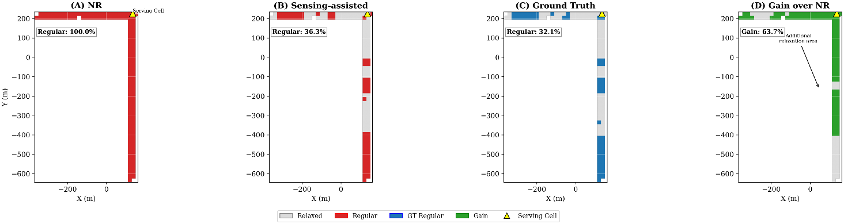
Figure 3: Comparison of measurement-relaxed regions between NR and sensing-assisted scheme.
The measurement relaxion can further be converted to the UE power consumption reduction according to TR38.840. Table 3 shows the sensing-assisted scheme can reduce the UE power consumption by 25.4% compared to the full NR measurement.
Table 3: UE power consumption comparison under TR 38.840 assumptions.
Measurement Scheme | Power Consumption | Power Saving vs. Baseline
Baseline (No relaxation) | 3.35 | -
Sensing-assisted Relaxation | 2.50 | 25.4%

- Sensing assisting beam management
Conventional beam management typically relies on blind beam sweeping, requiring the UE to monitor a large candidate beam set via periodic measurement and reporting. This approach incurs large measurement and reporting overhead, as well as high UE energy consumption. Introducing channel assisted information by sensing enables the network to optimize beam measurement, reporting, and beam indication.
Key simulation assumptions are summarized in Table 4.
Table 4: Key configurations of the simulation.
Parameter | Value
Deployment | Urban Grid with ISD 500m in Rel-19 ISAC channel model
Frequency Range | FR2 @30 GHz
Channel model | TR 38.901 UMa ISAC channel
Number of BS beams | 16 SSB beams, 16 CSI-RS beams, 256 beams in total.
Assisted information | candidate fine beam set.
SSB measurement error | 3dB standard deviation
CSI-RS measurement error | 3.25 dB standard deviation

The counterpart to be compared to is the NR P1-P2 measurement case. In the NR P1-P2 measurement, the SSB and CSI-RS measurement error would impact on detecting the optimal beams. Hence, the SSB and CSI-RS measurement error is assumed in the simulation. With that, the different beam sweep schemes are compared in terms of beam selection accuracy, characterized by the beam forming gain that is defined as the selected fine CSI-RS beam forming gain in P2 minus the selected coarse SSB beam forming gain in P1.
In the simulation, the assisted information is the candidate fine beam set with the corresponding region, which is extracted by the sensing measurement. Network and UE then perform the beam sweeping under the candidate fine beam set so as to reduce the beam sweeping effort. Figure 4 illustrates the beam selection accuracy comparison by different schemes. The orange curve is the NR P1-P2 scheme indicating about 6dB gain in mean value. The blue and green curves are the sensing-assisted scheme indicating 12dB and 9.8dB gain with and without the P2 sweeping, respectively. From the beam sweeping overhead perspective, the NR should sweep 16 fine beams in P2. The sensing-assisted scheme sweeps 3 fine beams or without the fine beam sweeping at all (e.g., when only one optimal fine beam in the candidate set). Therefore, the sensing assisted scheme can achieve a better beam management performance in terms of beam forming gain with a lower beam sweeping overhead.

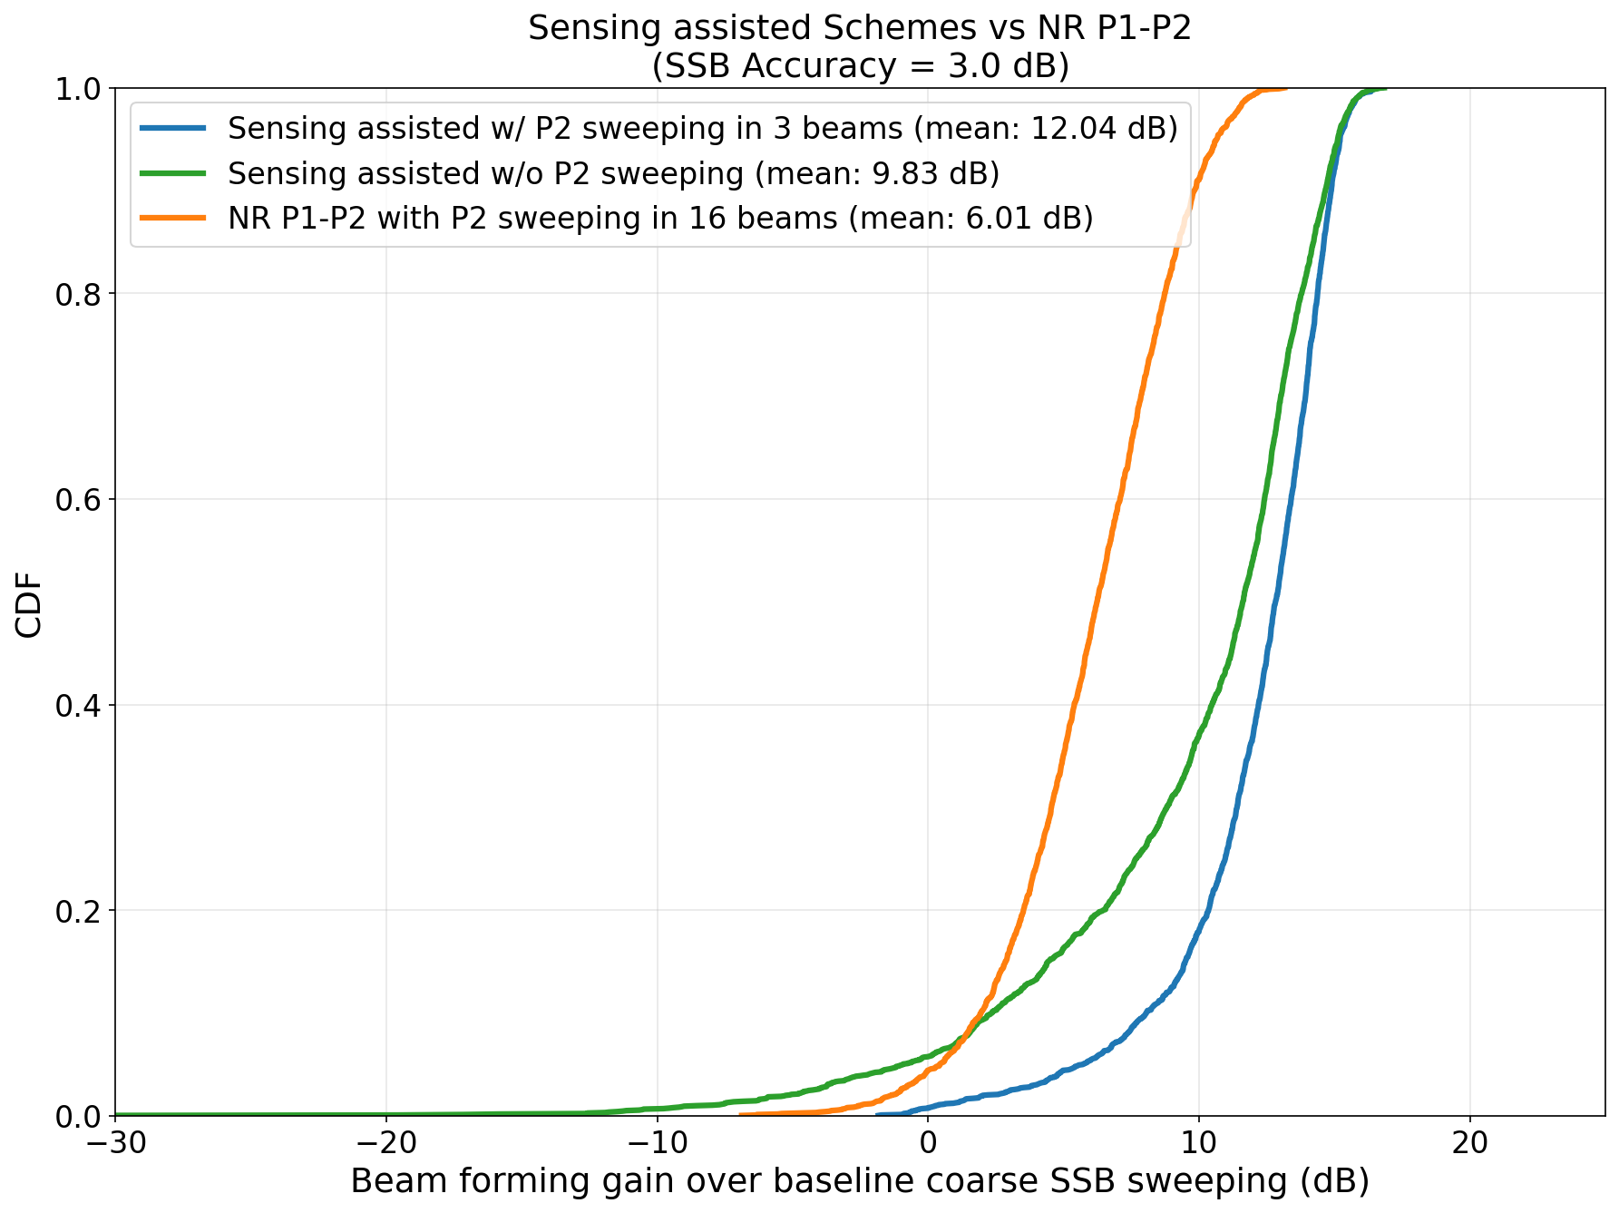
Figure 4: Beam forming gain comparison between the NR scheme and the sensing assisted scheme.

- Sensing assisting MIMO CSI acquisition
As shown in Figure 1, the communication channel’s multiple path components are generated by reflection, diffraction from objects in the surrounding environment. The multi-path components caused by stationary environment objects (e.g. building, wall etc.) are stable and tend to remain constant in a long term, and those multi-path components caused by moving object/scatters, variation results in short term fast fading.
In traditional MIMO CSI acquisition, real-time CSI measurement and feedback are utilized to acquire both long-term and short-term channel characteristics simultaneously. Obviously, such frequent measurement and feedback for the long-term channel components are not necessary since they are stable. If those long-term components can be obtained by some methods, it can help to save the CSI measurement effort and feedback overhead significantly. In such case, MIMO CSI acquisition just needs to focus on the short-term channel components variation with the acquired assisting information from long term channel components.
Thanks to the aNB-UE bi-static sensing capability, the stationary objects can be accurately detected and the channel components information associated with those objects can be obtained as long-term prior information to assist MIMO short-term CSI acquisition.
A simulation is conducted to investigate the channel characteristics in the urban grid scenario under ISAC channel model. From the network perspective, the departure angle of the dominant paths for the entire cell range can be spatialized into 7 clusters with the mean and width attribute across each cluster, based on the knowledge of the stationary objects obtained through sensing. Each cluster is associated with a consistent spatial area according to the mean and width. In other words, the users located in this spatial area share the similar spatial multiple path angles. In Figure 5, the power angle profile is shown to demonstrate the mapping between each cluster in the angular domain (AoD) and the corresponding region and also the table summarizing the AoD and ZoD characteristics of the clusters associated with each region. These clusters can be identified as the long-term clusters measured by the sensing measurement and quasi-stable in a large scale.
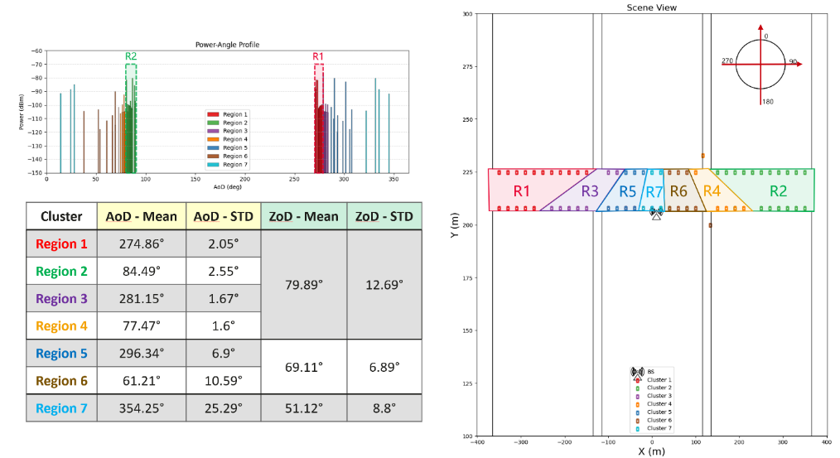
Figure 5: Dominant clusters measured by sensing measurement and their corresponding applicable regions.
Once the user obtains the long-term scaled cluster mean and width, the user can treat this information as a prior searching/operation angular sub-space for CSI acquisition purpose. With that, the UE can further search the fast-fading paths in the sub-space for different use cases within MIMO operation. For CSI-RS processing, UE can perform specified channel filtering/denoising based on the sub-space. For CSI reporting, an accurate while simple sub-space projection matrix/basis can be achieved by rotating operation on the non-DFT basis without the complicated basis searching and/or high-resolution basis calculation, e.g., eigen based basis.
Preliminary results have verified that in scenarios with 256 ports or more, the CSI-RS overhead can be reduced to about one-tenth of the original level with legacy CSI-RS pattern/density design, while the performance loss is less than 3%. Targeting the UPT performance close to that of the eType II codebook (e.g., 85%+), the feedback overhead can be reduced as low as the Type I codebook feedback level. The detailed information on how to utilize the assisting information can refer to [4].
Therefore, leveraging channel information assisted by sensing measurement would benefit the CSI-RS overhead reduction and the low overhead feedback with high resolution CSI requirement in 6G.
In shorts, the commonality of sensing assisting communication is the spatial-temporal consistent channel information detected by the sensing measurement. Once the channel can be detected accurately, the corresponding assist/prior information can be further generated according to the downstream communication features, which are summarised in Table 5.
Table 5: Assist/prior information generated by sensing measurement to assist different communication features.
Commonality | Channel information measured by sensing.
Assisted communication features | Mobility/handover | Beam management | CSI acquisition
Assist/prior information | Measurement candidate beam set, handover indicator, etc. | Candidate beam set | Long-term Cluster mean and width

Proposal 7: For sensing assisting communication, a unified channel measurement report (i.e., measurement content/format) for both sensing and communication should be studied for aNB-UE bi-static sensing mode.
Proposal 8: For sensing assisting communication, RAN1 to study how to acquire the channel characteristics by sensing measurement to assist communication.
Proposal 9: For sensing assisting communication, RAN1 to study the applicable use cases, e.g., mobility, beam management, CSI acquisition.

5.2 Type2 resources for sensing and comm.
The measuring for the use case of sensing assisting communication is less demanding compared to the use case of detection/tracking and it is hopeful to meet the sensing requirement by reusing the common or shared resource with communication, including physical channel/signal.
In terms of physical channel/signal, reference signals (e.g., SRS, CSI-RS) are the typical resources of interest for sensing study. Moreover, other channels, e.g., control/data channels are also possible, e.g., for aNB mono-static sensing since aNB is perfectly aware what is conveyed on the channel(s).
The study on type2 resources for sensing and communication includes the waveform design for physical channels, reference signals including the RS patterns and RS sequences. Performance for both sensing and communication together with other aspects such as complexity if additionally added on needs to be studied.
Proposal 10: 6GR ISAC should study on using UL/DL reference signals (e.g., SRS, CSI-RS) and the physical channels (e.g., control/data) for sensing on Type2 resources that are shared with communication, including
- On the physical channels, the waveform design;
- On UL/DL reference signals, the RS patterns and RS sequence.

Note that the performance benchmark should take the assumptions (e.g., waveform, RS design) from 5G/5GA as the starting point and can be adjusted accordingly as the discussion for communication progresses further.
Proposal 11: The study on Type2 resources for sensing and communication, the performance benchmark takes the assumptions (e.g., NR waveform, RS design) from 5G/5GA and can be adjusted accordingly as the study for communication progresses further.

5.3 Type2 measurement report
Agreement:
- On measurement report for ISAC, study at least the following aspects and applicable scenarios (e.g., sensing modes, targets, etc.) from RAN1 perspective.
  - Measurement reporting mechanism from UE
    - Option 1A: The UE measurements and/or assistance information if needed from UE can be directly sent to aNB
    - Option 1B: The UE measurements and/or assistance information if needed from UE can be sent to SF
  - Measurement reporting mechanism from aNB
    - Option 2A: The aNB measurements and/or assistance information if needed from aNB can be directly sent to UE
    - Option 2B: The aNB measurements and/or assistance information if needed from aNB can be sent to SF
  - The study may require cross-WG coordination.
  - Note: combination of multiple options is not precluded.
  - Note: measurements in each option may be different

The Type2 measurement report targets the use case of sensing assisting communications. As discussed in section 5 about the framework for sensing assisting communication, UE measures RS and reports the measurement to aNB will be straightforward which is in line with UE reporting CSI-RS to aNB as well for aNB-UE bi-static sensing. Depending on how the communication will be assisted, aNB may further forward the measurement from UE to core network. For UE-aNB bi-static sensing, it is clear that aNB measures the RS and may further reports the measurement to core network.

Proposal 12: The Type2 measurement report targets the use case of sensing assisting communications,
- for aNB-UE bi-static sensing mode, UE measures the RS and reports the measurement directly to aNB;
- for UE-aNB bi-static sensing mode, aNB measures the RS.

Measurement and assistance information
Agreement:
- On measurement for ISAC, study at least the following aspects.
  - Measurement definitions/levels for TRP-side measurement, taking the measurement Levels studied in NR ISAC as starting point
  - Measurement definitions/levels for UE-side measurement
  - Impacts of non-ideal factors on measurement
  - Other aspects are not precluded
  - Note: this discussion may or may not mean there is specification impact

NR 5G-A study on ISAC defined the measurement that is captured in TR38.765 for base station mono-static sensing mode. For 6GR ISAC study aNB-UE or UE-aNB bi-static sensing, the measurement definition/level should consider which entity performs the measurement and which entity reports the measurement. For example, when discussing the measurement level measured by UE, the underlying assumption is that TRP location should not be known to UE. Regarding whether UE measures/reports the departure angle and/or the arrival angle, we think both might be needed in some cases. For example, when the aNB-ST link is NLOS status, if UE can measure both departure and arrival angles, with the EO type-2, the detection performance for the ST in NLOS will be much improved.
Moreover, the measurement definition or the contents to be reported might be different for the detection/tracking case from for the sensing assisting communication case. As shown in Table 6, the propagation path characteristics of interest are different for the use case of moving target detection from the case of sensing assisting communication, which results in the different measurement contents expected for the measurement reports.
Table 6: Measurements for sensing for different channel scatter types.
Channel scatter types | Channel path characteristics | Sensing tasks | Measurements for sensing
Moving targets | Fast varying and weak power | Target detection | Report measurement of delay, doppler, angle
Static objects | Stable, spatial consistent, strong power | Assisting communication. | Report measurement of delay, angle, power
Stochastic clusters | Fast varying and weak power | / | To be eliminated from the measurements reported for sensing.

Furthermore, when discussing the measurement report entity, the measurement overhead should be especially considered for UE reporting the measurement via uplink air interface resources. Considering the essence of the sensing measurement being to detect the interested propagation multiple paths component accurately, it is feasible for UE to report the interested paths instead of the entire profile since the original profile would be redundant with some background channel of very low power paths that is not helpful for target detection or assisting communication purpose anyway. In such a way, UE reporting overhead will be much reduced compared to reporting the entire profile as illustrated in Figure 6.

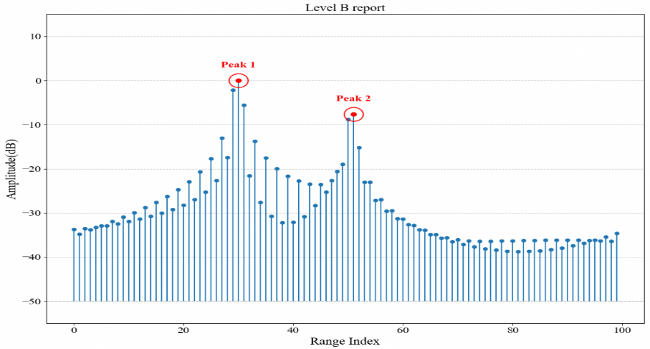
Figure 6: Detected paths from the power-delay profile.
In terms of the measurement volume, taking aNB-UE bi-static sensing mode as an example, based on the measurement definition from TR38.765, the data volumes for different types of measurements for the case of sensing assisting communication are analysed and summarized in Table 7. The payload size analysis can be found in Annex.
Table 7: The data volumes for different types of measurements for sensing assisting communication
Measurement report level | Payload size | Remarks
Level A: Raw data | In the order of 100Mbits | Large data volume
Level B: Delay/doppler/angle profile | In the order of 100Mbits
Level C: Detected paths | In the order of 100bits | Small data volume

Proposal 13: In terms of measurement definition, for UE reporting the measurement for aNB-UE bi-static sensing, UE reports the detected paths with the associated characteristic, e.g., delay, angle, power, phase.
- How to further reduce the measurement report overhead can be further studied, e.g., using window, eliminating the background channel, etc.
- The characteristics of the detected paths to be reported might be different depending on the sensing use cases.
- For UE reporting the arrival angle, the UE reports the angle in GCS; for UE reporting the departure angle, UE reports the angle index corresponding to the measured multiport RS.

Phase discontinuity issue

[FL1][H] Proposal 4.4-1-rev1
- On phase continuity for DL/UL sensing RS, study at least the following aspects.
  - Aspects to maintain phase continuity in a CPI
  - Events causing phase discontinuity, e.g., TDD UL/DL switch, change of power/TA, etc.
  - Whether/how to recover phase continuity?
  - Other aspects are not precluded

The phase discontinuity issue was discussed in the last meeting but focused on the issue within a coherent processing interval (CPI). In our view, phase discontinuity may happen for SRS hopping to be used for sensing needs to be studied as well.
For sensing based on coherent processing within a CPI, phase continuity across sensing RS occasions is expected so as to more accurately reflect the Doppler-induced phase rotation of the target. If an unknown phase discontinuity is introduced within the CPI, the coherent processing gain may be reduced and the range-Doppler (RD) profile may be distorted, e.g., peak loss, Doppler spreading, increased sidelobes, or false peaks in the RD spectrum, etc.
- Investigation on the impact by phase discontinuity events within a CPI
A simulation is conducted to investigate the impact of the phase discontinuity in time domain, taking the CPI length of about 40ms under a DDDSU TDD operation as an example. The Figure 7 shows the doppler spectrum impact with different phase joggling times. For one-time random phase joggling, an increased side lobe may or may not impact the final velocity accuracy depending on the detection algorithm. However, when multiple phase jogging happens, e.g., each DL/UL switch introduce a random phase joggling within a CPI, the doppler spectrum degrades significantly and causes detection failed.
Whether should the TA adjustment be considered for the phase discontinuity issue? Firstly, TA adjustment is occasional rather than a fixed-period event. Secondly, TA maintenance is controlled by network commands and timers and the time scale of time alignment maintenance is typically in second level which is larger than a CPI length, which implies that there is less than one-time TA adjustment during one CPI. Therefore, in our view, there is no need to consider the special handling for the potential TA adjustment during the CPI length from either network nor UE perspective.
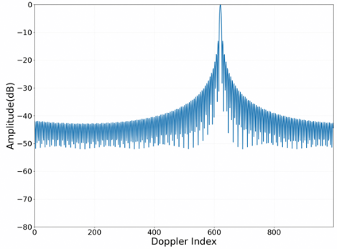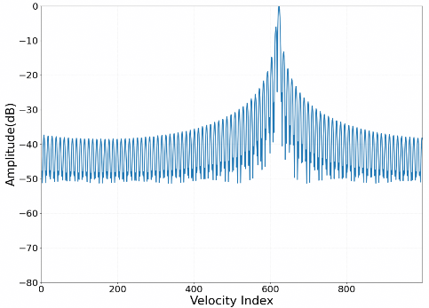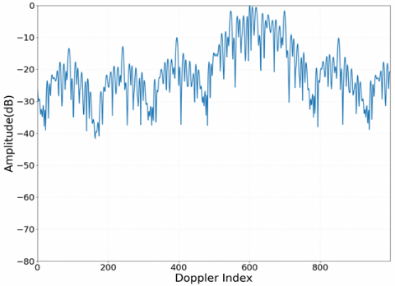
Figure 7: Impact of the phase continuity caused by DL/UL switch: doppler spectrum without phase joggling(left), doppler spectrum with one-time phase joggling(middle), doppler spectrum with multiple times phase joggling (right).
Observation 1: Doppler detection is tolerable to a certain random phase joggling. DL/UL switch is the main factor that introduces the random phase joggling within the CPI.

Whether should the transmission power adjustment be considered for the phase discontinuity issue? To investigate the transmission power adjustment, firstly, we assume the PA is working in the linear zone and the phase will keep stable with the PA adjustment. In the simulation, the transmission power during the second half of the CPI is assumed to be 6dB higher than in the first half and the phase continuity is kept during the DL/UL switch. The Figure 8 shows that the shape of the doppler spectrum changes slightly and does not impact the doppler detection.
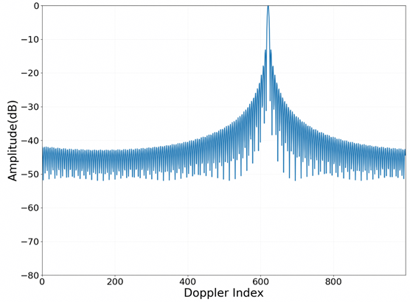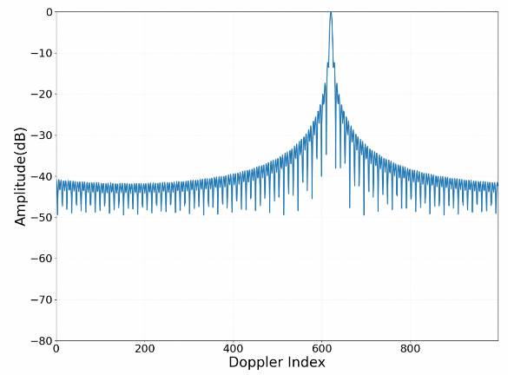
Figure 8: Impact of the phase continuity caused by PA adjustment: doppler spectrum without power adjustment(left), doppler spectrum with 6dB power adjustment(right).
Observation 2: The impact of transmission power adjustment within a CPI is tolerable for doppler detection.
- Whether/How to recover phase continuity?
As discussed above, the DL/UL switch in TDD operation is the main factor that introduces the random phase joggling within the CPI.
To address this, two categories of mechanisms can be considered. One potential way is to utilize a reference path to estimate the phase joggling and compensate the phase of the other paths within a CPI. The reference path can be a direct LOS path, a strong static reflection path, or other possible strong and stable path identified by sensing measurement. The other way is to utilize the RS to estimate the phase joggling and compensate the phase discontinuity when the DL/UL switching occur within the CPI.
For the transmission power adjustment, the impact on doppler detection is tolerable, no need to consider the special handling from either network nor UE perspective.
Proposal 14: RAN1 study how to address the phase discontinuity caused by DL/UL switch within a CPI, e.g., reference path, utilize RS to estimate the phase discontinuity.
Proposal 15: The necessity of the special handling for the transmission power adjustment or timing advance adjustment from either network nor UE perspective on the phase discontinuity issue within a CPI should be justified before discussing the special handling details.

- Investigation on the impact by phase discontinuity events in frequency domain
In addition to the coherent processing during an interval over time domain for which the phase continuity is expected, the phase is also expected to be continue without joggling across the SRS transmission hops.
For SRS to be used for communication and sensing, in general two categories could be considered. One is non-frequency-hopping transmission, where the measurement of the full channel bandwidth is acquired through a single transmission. The other is frequency-hopping transmission, where the measurement of the full channel bandwidth is obtained through multiple transmissions in a frequency hopping manner.
The sensing performance benefits from the channel measurements with high SNR and large bandwidth. A single transmission without frequency-hopping will be preferred. However, the low Power Spectral Density (PSD) will be an issue. Reducing the RS PAPR will be of interest for the study. This issue will be discussed in [3].
For frequency-hopping SRS transmission, each SRS transmission occupies only a fraction of the channel bandwidth. The channel measurement for communication purpose over the entire channel bandwidth can be acquired via multiple frequency-hopping transmissions, where no requirement is imposed on the phase continuity between channel measurements from different hopping sub-bands for communication purpose. However, the combination of non-coherent channel measurements acquired from multiple frequency-hopping sub-bands cannot serve as a valid equivalent to the channel measurement acquired by non-frequency-hopping wideband SRS, which results in significant degradation of the sensing performance, especially for inter-slot frequency hopping SRS as shown in Figure 9. Hence, for SRS used for sensing, resolving the phase discontinuity for SRS with frequency hopping is an important aspect for the study.
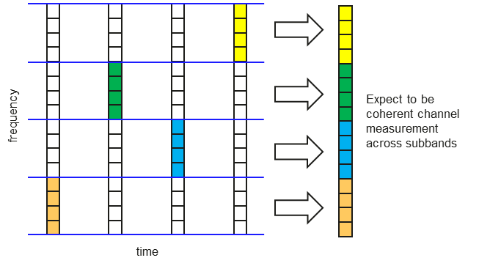
Figure 9: Combination of channel measurements acquired from inter-slot frequency-hopping SRS.
There are some potential solutions can be considered. For instance, the phase discontinuity of SRS transmissions across different hops can be compensated by introducing frequency-domain overlapping resources as discussed for RedCap UEs in Rel-18. In addition, how to enable it within the typical frequency-hopping SRS pattern for MIMO should be considered.

Proposal 16: For SRS with frequency hopping to be used for communication and sensing, RAN1 to study how to address the phase discontinuity of the SRS transmissions across different sub-bands.

RS design
Regarding the RS to be used for sensing, last meeting agreed the following:
Agreement:
- On RS for ISAC, study at least the following aspects, considering sensing performance, resource overhead and impact to communication
  - RS for communication is reused for sensing
  - Enhanced RS for sensing, taking reuse of RS for communication as starting point
    - Note: Part of or all of the RS may be used for communication purpose, and it does not mean the final decision on whether the enhanced RS is used for communication purpose is to be made in this agenda.
  - Dedicated RS for sensing

Agreement:
- Study RE patterns of RS for sensing, considering sensing performance, resource overhead and impact to communication
- Note: enhancements on RS sequence if any will be discussed in agenda 10.8.3

Starting from NR RS pattern before seeing concrete progress on the RS pattern for 6GR communication, the uniform pattern in both frequency and time domains will be considered and study the necessity of non-uniform pattern for sensing. The study includes the Doppler-related sensing performance, RS overhead, impact on communication, UE or network implementation complexity if any, etc.
For the study on the non-uniform RS pattern, two possible approaches to obtain the time-domain non-uniform RS pattern can be considered.
  - The first approach is to combine multiple regular RS sub-patterns as shown in Figure 10. For example, multiple uniform RS sub-patterns can be configured and activated simultaneously, where each sub-pattern has its own periodicity and offset. The union of these sub-patterns forms a non-uniform overall RS pattern for sensing. This approach is compatible and friendlier to the uniform RS configuration framework as in NR and might be friendlier to UE and network implementation as well.
  - The second approach is allowing the most flexible non-uniform pattern for sensing.
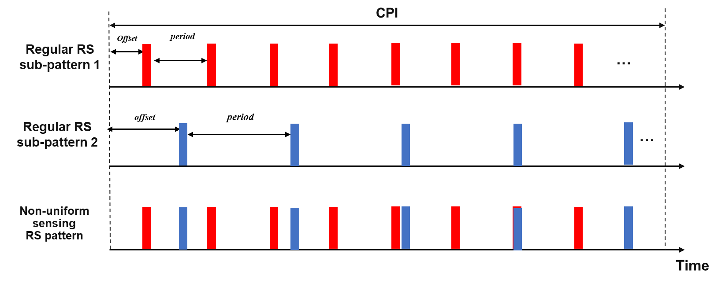
Figure 10: Non-uniform RS enabled by multiple regular RS patterns.

Proposal 17: The uniform pattern in both frequency and time domains will be considered and study the necessity of non-uniform pattern for sensing considering the following two approaches. The study includes the Doppler-related sensing performance, RS overhead, impact on communication, UE or network implementation complexity if any.
  - Combining multiple regular RS sub-patterns to form a non-uniform RS pattern in time domain;
  - Allowing the flexible non-uniform RS pattern for sensing.

Networked sensing
Multi-link networked sensing helps improve sensing accuracy
Making use of multiple links can expand the overall sensing coverage and improve sensing performance as illustrated in Figure 11. While the single link between BS1 and the sensing target is blocked, other links, such as BS2-target-BS2 and BS2-target-UE may remain visible. Hence, by combining measurements from multiple links, ‘blind spots’ are substantially reduced. Furthermore, fusing sensing measurements of multiple links can improve sensing performance in terms of lower false alarm rate and higher location accuracy.
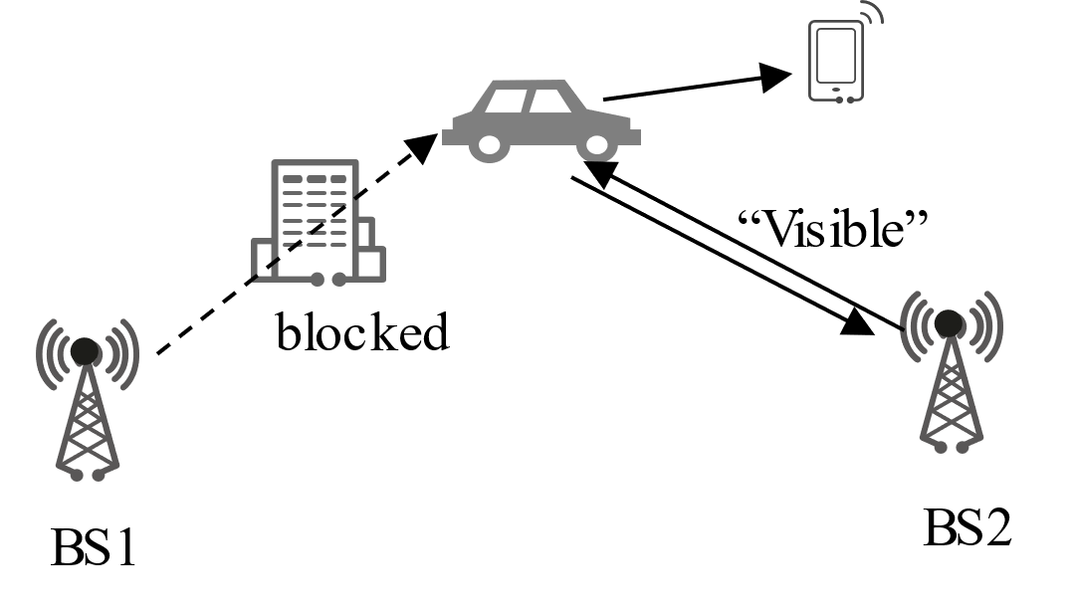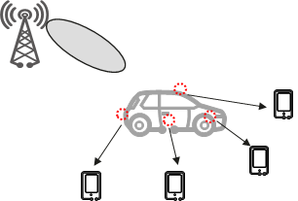
- Sensing coverage expansion (b) Sensing performance improvement
Figure 11: Multiple links expand the overall sensing coverage and improve sensing performance.
A simulation comparing BS-only monostatic sensing and BS-UE bistatic sensing is shown in Table 8. With surrounding UEs, more links are involved and NLOS targets out of BS-only sensing coverage are detected.
Table 8: Comparison between monostatic sensing and bistatic sensing.
 | Monostatic sensing  (BS only) | Bistatic sensing  (BS-UE)
Target  detection rate | 71%  (only LOS targets) | 100%  (LOS & NLOS targets)

Furthermore, multi-link fusion demonstrates performance improvements across various scenarios, such as target detection/tracking, positioning, etc. For target detection, multi-link sensing reduces spurious target detection by cross-verifying multi-view observations. As shown in Table 9, the false alarm rate of networked sensing is reduced by 24% compared to single-link sensing. Moreover, the location accuracy of sensing target including both horizontal and vertical accuracy can also be improved as shown in Table 9.
Table 9: Comparison between single-link sensing and networked sensing.
 | Single-link sensing  (BS-UE bi-static sensing) | Networked sensing
False alarm rate | 26.5% | 2.1%
Horizontal_Position_Error@90% (m) | 2.22 | 0.93
Vertical_Position_Error@90% (m) | 0.22 | 0.03

Interference to be considered for networked sensing

[FL1][H] Proposal 4.7-1
- On interference handling for ISAC, study at least the following aspects, to mitigate the interference between sensing signals and between sensing and communication.
  - Transmitter-side interference avoidance/coordination
  - Receiver-side interference cancellation
  - Interference measurement/report
    - Interference resource/report configuration
    - Interference measurement quantities
    - Interference measurement report
  - Other solutions for interference handling are not precluded
When come to making use of multiple sensing links for sensing performance improvement while UEs need to maintain communication in the cell, the interference related issues need to be studied inevitably as for communication.
For communication, UEs could be configured with resources for interference measurement and report. In detail, the inter-cell interference power is typically quantified with metrics such as RSRP/RSRQ/SINR within the same time-frequency domain for communication, so that it helps BS schedule the proper time-frequency domain resources with less interference for communication.
While the UEs need to measure the RS for sensing purpose as well, the interference might be distinct from that for communication since the sensing measurement result is obtained based on delay-doppler-angle domain. As shown in Figure 12, with inter-cell interference for sensing, the sensing target detection will be difficult.
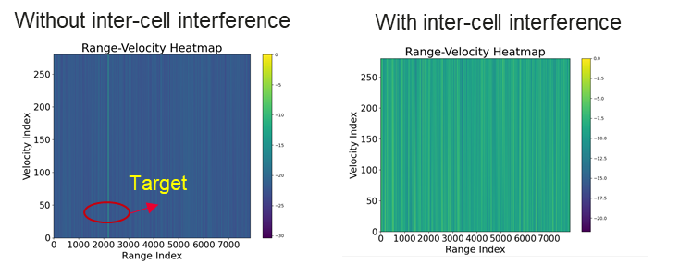
Figure 12: The inter-cell interference may result in target detection failure.
For sensing IM (interference measurement) resource, as shown in Figure 13, the communication CSI-RS pattern on the left is different from that for IM on the right. When the CSI-RS is treated as sensing RS, these two RS patterns lead to different delay-doppler domains with different ambiguity range and resolution, where the IM pattern on Figure 13 leads to 4 times larger doppler and delay unambiguous range with 1/4 and 1/8 resolution, respectively.
As a result, it is inaccurate to evaluate the interference quality in, e.g., a delay-doppler domain, for sensing measurement by using the communication IM resource. For example, the communication IM detection area is 1/16 of the CSI-RS detection area in the delay-doppler domain as shown in Figure 14, which means the communication IM resource cannot reflect the signal quality in the domain for sensing measurement. Thereby, it is necessary to study the proper sensing IM resource design with the same ambiguity range as the sensing RS in serving cell, and possible resource overhead reduction.
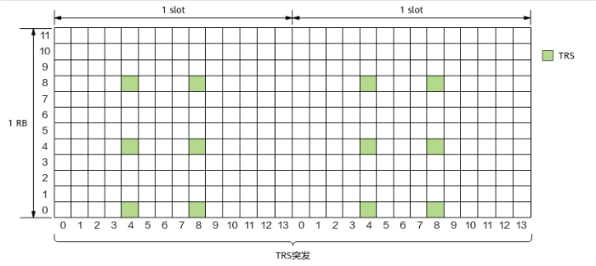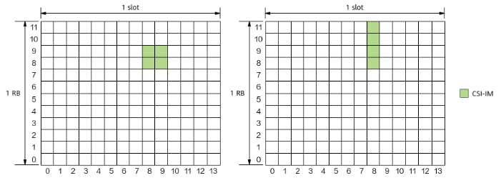
Figure 13: Left: CSI-RS, Right: communication IM RS.
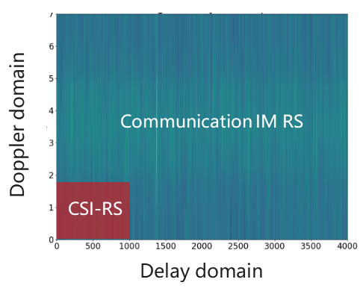
Figure 14: The detection area for sensing in the delay-doppler domain using communication IM and CSI-RS.
Proposal 18: RAN1 to study inter-cell operation aspects for sensing, e.g., interference measurement, management and report.
- The sensing interference measures the RSRP/RSRQ/SINR defined in the interested domain for sensing, e.g. delay-doppler domain, delay-angle domain, etc.
- The sensing interference measurement RS is expected to keep the same ambiguity range in the interested domain for the sensing measurement.
- The sensing interference measurement RS resource overhead reduction will be considered.

Other issues
In the last meeting, other issues, e.g., beam management, power control, Timing advance, etc., was summarized in Feature Lead summary, we will discuss such issues in this section.

[FL1][H] Proposal 4.6-1
- On beam management for ISAC, study at least the following aspects, taking communication beam management as starting point.
  - TCI states/QCL types
  - Beam-related measurement quantities
  - Beam resource/report configuration
  - Beam sweeping
  - Beam report ：
  - Beam indication
  - Beam maintenance and failure recovery
  - Other aspects are not precluded

[FL1][H] Proposal 4.8-1-rev1
- On power control for ISAC, study at least the following aspects, considering both sensing performance and impacts to communication.
  - P0/alpha
  - Pathloss reference
  - CL PC
  - PHR
  - DL PC
  - Impact to phase continuity within CPI
  - Other aspects are not precluded

From the propagation channel perspective, the path loss of target channel is much lower than the path loss of the direct LOS path and specular reflection path due to the RCS loss, which has been identified in Rel-19 ISAC channel model.
Firstly, for power control mechanism for communication, the transmitter only needs to adjust the transmission power based on the received RSRP or the pathloss for which the LOS and/or the reflection path dominate the power. However, for sensing, there are many potential target paths with different pathloss values or the received RSRP values that makes adjusting the power for each path infeasible.
Secondly, from the hardware perspective, the sensing and communication share the same power amplifier either in base station or in user equipment. The transmitter increases the power according to the weak path may lead to the power amplifier working in the non-linear zone which is not energy efficient or lead to the maximum transmission power of UE always that in turn loses the point of power control.
Regarding the beam management for sensing, comparing to the beam management for communication that will be performed anyway for communication in FR2, the additional specific handling for sensing does not seem necessary.
Proposal 19: Communication-based beam management and power control mechanisms are applicable to sensing. No specific handling is needed for sensing.

Conclusions
In this contribution, we discussed the use cases, sensing modes, resources for measurement, measurement reports, sensing assisting communication, and the issues to be studied for networked sensing, which leads to the following proposals:

Observation 1: Doppler detection is tolerable to a certain random phase joggling. DL/UL switch is the main factor that introduces the random phase joggling within the CPI.
Observation 2: The impact of transmission power adjustment within a CPI is tolerable for doppler detection.
Proposal 1: aNB-UE and UE-aNB bi-static sensing should be prioritized for 6GR ISAC study.
Proposal 2: How UE location is known for aNB-UE or UE-aNB bi-static sensing modes for sensing result calculation in Core Network can be studied first in SA2 and further coordinated with RAN when needed.
Proposal 3: 6GR ISAC should study two types of wireless resources (i.e., physical channel/signal) for sensing:
- Type1 resource is sensing performance oriented, e.g., additional time domain reference signal that enables detection of moving targets but not necessarily needed for communication.
- Type2 resource is shared with communication and the design is expected to provide good performance for both sensing and communication.

Proposal 4: 6GR ISAC study on Type1 resources for optimal sensing performance oriented should focus on using UL/DL reference signals for sensing.

Proposal 5: The study on using UL/DL reference signals for Type1 resources for sensing performance oriented includes the RS patterns and RS sequences.
- Performance for sensing is the optimization objective.
- Impact to communication is the resource overhead for sensing.
Proposal 6: The Type1 measurement report targets the use case of detection/tracking, for which the measurements are reported to core network that is expected to be responsible for initiating the sensing task and calculating the sensing results.
- For aNB-UE bi-static sensing mode, UE measures the RS and reports to core network via aNB but aNB does not need to use such information.
- For UE-aNB bi-static mode, aNB measures the RS and reports to the core network.
Proposal 7: For sensing assisting communication, a unified channel measurement report (i.e., measurement content/format) for both sensing and communication should be studied for aNB-UE bi-static sensing mode.
Proposal 8: For sensing assisting communication, RAN1 to study how to acquire the channel characteristics by sensing measurement to assist communication.
Proposal 9: For sensing assisting communication, RAN1 to study the applicable use cases, e.g., mobility, beam management, CSI acquisition.
Proposal 10: 6GR ISAC should study on using UL/DL reference signals (e.g., SRS, CSI-RS) and the physical channels (e.g., control/data) for sensing on Type2 resources that are shared with communication, including
- On the physical channels, the waveform design;
- On UL/DL reference signals, the RS patterns and RS sequence.
Proposal 11: The study on Type2 resources for sensing and communication, the performance benchmark takes the assumptions (e.g., NR waveform, RS design) from 5G/5GA and can be adjusted accordingly as the study for communication progresses further.
Proposal 12: The Type2 measurement report targets the use case of sensing assisting communications,
- for aNB-UE bi-static sensing mode, UE measures the RS and reports the measurement directly to aNB;
- for UE-aNB bi-static sensing mode, aNB measures the RS.
Proposal 13: In terms of measurement definition, for UE reporting the measurement for aNB-UE bi-static sensing, UE reports the detected paths with the associated characteristic, e.g., delay, angle, power, phase.
- How to further reduce the measurement report overhead can be further studied, e.g., using window, eliminating the background channel, etc.
- The characteristics of the detected paths to be reported might be different depending on the sensing use cases.
- For UE reporting the arrival angle, the UE reports the angle in GCS; for UE reporting the departure angle, UE reports the angle index corresponding to the measured multiport RS.
Proposal 14: RAN1 study how to address the phase discontinuity caused by DL/UL switch within a CPI, e.g., reference path, utilize RS to estimate the phase discontinuity.
Proposal 15: The necessity of the special handling for the transmission power adjustment or timing advance adjustment from either network nor UE perspective on the phase discontinuity issue within a CPI should be justified before discussing the special handling details.
Proposal 16: For SRS with frequency hopping to be used for communication and sensing, RAN1 to study how to address the phase discontinuity of the SRS transmissions across different sub-bands.
Proposal 17: The uniform pattern in both frequency and time domains will be considered and study the necessity of non-uniform pattern for sensing considering the following two approaches. The study includes the Doppler-related sensing performance, RS overhead, impact on communication, UE or network implementation complexity if any.
  - Combining multiple regular RS sub-patterns to form a non-uniform RS pattern in time domain;
  - Allowing the flexible non-uniform RS pattern for sensing.
Proposal 18: RAN1 to study inter-cell operation aspects for sensing, e.g., interference measurement, management and report.
- The sensing interference measures the RSRP/RSRQ/SINR defined in the interested domain for sensing, e.g. delay-doppler domain, delay-angle domain, etc.
- The sensing interference measurement RS is expected to keep the same ambiguity range in the interested domain for the sensing measurement.
- The sensing interference measurement RS resource overhead reduction will be considered.
Proposal 19: Communication-based beam management and power control mechanisms are applicable to sensing. No specific handling is needed for sensing.

References
- RP-260073, RAN TR 38.914, Study on 6G scenarios and requirements (Release 20), V0.4.0 (2026-03).
- RP-251881, New SID: Study on 6G Radio, NTT DOCOMO (Moderator), RAN#108, Prague, Czech Republic, June 9-13, 2025.
- R1-2601945, Waveform and signal for 6GR ISAC, Huawei, HiSilicon, RAN1#124bis, St Julian’s, Malta, April 13-17, 2026.
- R1-2604267, Aspects of downlink-based CSI acquisition, Huawei, HiSilicon, RAN1#125, Dalian, China, May 18-22, 2026.

Annex
Based on the use-case-dependent measurement requirements discussed above, the payload size of different measurement outputs is evaluated in this subsection. The objective is to understand whether the candidate measurement outputs are practically feasible for UE reporting.
For simplicity, the payload size is expressed below for the case of a single TRP-UE link.
- Level A: raw data
For raw data, the payload size is calculated based on the number of subcarriers, the Tx/Rx antenna ports, and the quantization bits of amplitude and phase:
$$Payload_{A}= N_{subcarrier}∙N_{txport}∙N_{rxport}∙ \left(Q_{amplitude}+Q_{phase}\right)$$
- Level B: delay-angle profile
For delay-angle profile, the payload size is calculated based on the number of delay samples, the numbers of Tx/Rx angle samples, and the quantization bits of amplitude and phase:
$$Payload_{B}= N_{delay}∙N_{txangle}∙N_{rxangle}∙ \left(Q_{amplitude}+Q_{phase}\right)$$
- Level C: Detected path
For detected paths, the payload size is calculated based on the number of reported paths and the quantization bits of the associated path parameters, including delay, angles, power and phase:
$$Payload_{C,path}= N_{path}∙\left(Q_{delay}+Q_{aoa}+Q_{zoa}+Q_{aod}+Q_{zod}+Q_{path,power}+[Q_{path,phase}]\right)$$

The representative parameter assumptions are summarized in Table 10.
Table 10 Representative parameter assumptions for payload evaluation
Parameter | Value / assumption
$$N_{subcarrier}$$ | 1083 (1 RE per RB for 400 MHz with guard band, 30 kHz SCS)
$$Q_{amplitude}$$ | 16
$$Q_{phase}$$ | 16
$$N_{delay}$$ | 2048
$$N_{path}$$ | About 10 for static and strong channel paths
$$Q_{delay}$$ | 12 (based on an FFT size of 4096, consider x2 oversampling factor)
$$Q_{aoa}$$ | 12 (dynamic range: 0 degree~360 degrees, quantization step: 0.1 degree)
$$Q_{zoa}$$ | 11 (dynamic range: 0 degree~180 degrees, quantization step: 0.1 degree)
$$Q_{aod}$$ | 12 (dynamic range: 0 degree~360 degrees, quantization step: 0.1 degree)
$$Q_{zod}$$ | 11 (dynamic range: 0 degree~180 degrees, quantization step: 0.1 degree)
$$Q_{path,power}$$ | 7 (reused from RSRPP dynamic range: -156dBm~-31dBm, RSRPP quantization step:1dBm)
$$Q_{doppler}$$ | 9 (dynamic range: -120km/h ~ 120km/h, quantization step: 0.47km/h)
$$Q_{path,phase}$$ | 12 (dynamic range: 0 degree~360 degrees, quantization step: 0.1 degree)

